CHAPTER-6 Admin Management

6.0 Introduction to Admin Management
Admin Management serves as the centralized administration layer of the platform, providing authorized users with the tools required to configure, monitor, and govern core system functions. It enables effective management of users and access roles, project oversight, master data maintenance, and configuration of platform-level features such as Copilot settings. This module ensures operational consistency, data integrity, and secure access control, supporting reliable and scalable platform operations.

6.1 Purpose and Scope of the Admin module
The Admin Module is designed to provide centralized control and governance over the platform. It empowers administrators to manage users, data, and configurations efficiently while ensuring security, consistency, and smooth system operations.
Purpose
- To centrally manage platform users, roles, and access permissions.
- To maintain and govern master data used across all modules.
- To oversee and control project-level configurations and workflows.
- To configure and manage system-level features such as Copilot settings.
- To ensure data integrity, compliance, and secure platform usage.
Scope
- User Management: Create, update, and control user accounts and role-based access.
- Project Management: View, manage, and monitor projects across the platform.
- Master Data Management: Define, update, and maintain core reference data.
- Configuration Management: Manage global and feature-specific settings.
- Platform Governance: Enable consistent operations, audit readiness, and administrative oversight.
Overall, the Admin Module acts as the foundation for effective platform governance, ensuring that all users, data, and configurations operate in a controlled, secure, and scalable environment.

6.2 User Management Module
Overview
The User Management module under Admin Management enables administrators to create, view, and manage platform users along with their assigned roles. This module ensures controlled access, role-based permissions, and secure onboarding of users to the NPCYF platform.
Navigation Path:
Dashboard → Admin Management → User Management
Screen Components
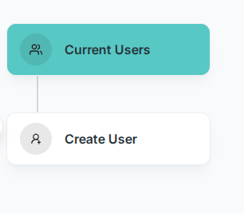
Current Users
- Displays the list of all existing users registered on the platform.
- Allows administrators to review users and verify role assignments.
- Serves as a reference before creating new users to avoid duplication

Create User
- Used to add a new user to the platform.
- Opens the Enter User Details form where user credentials and role information are captured.

6.2.1 Current Users
The Current Users section displays a consolidated list of all users who are registered on the NPCYF platform. This view enables administrators to monitor and review existing user accounts and their assigned roles.
Table Details
Each row in the table represents a user and includes the following information:
- Username – The unique login identifier assigned to the user.
- First Name – The user’s given name.
- Last Name – The user’s surname.
- Email – The registered email address associated with the user account.
- Role – The role assigned to the user, which defines their access level and permissions within the platform.
Purpose
- Provides visibility into all active users on the platform.
- Helps administrators verify role assignments and access levels.
- Supports governance, auditing, and access control management.
This section serves as a quick reference for administrators to ensure that user access is aligned with platform roles and responsibilities.
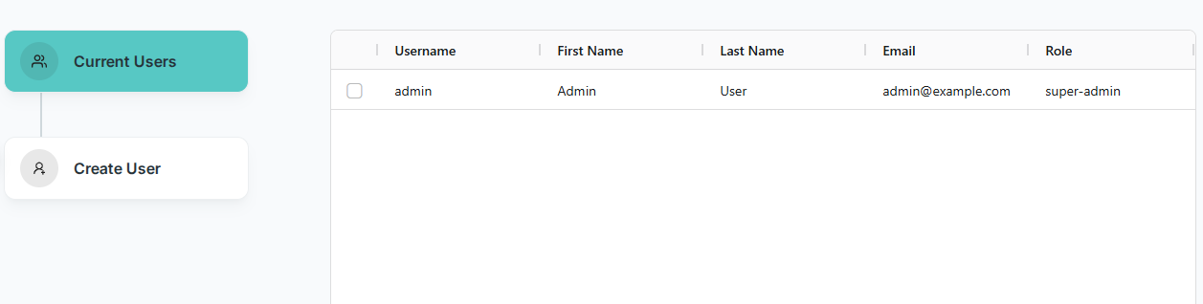

2.2.2 Create User
The Create User section enables administrators to onboard new users onto the NPCYF platform by capturing essential credentials and assigning role-based access. This ensures secure, structured, and controlled access to platform functionalities.
Fields Description
- Username
Enter a unique username that will be used by the user to log in to the platform.
- Password
Set a secure password for the user. The password visibility toggle (eye icon) can be used to view or hide the entered password.
- First Name
Enter the user’s first name for identification and official records.
- Last Name
Enter the user’s last name.
- Email
Provide a valid email address associated with the user for communication and account-related notifications.
- Select Role (Mandatory)
Assign an appropriate role to define the user’s access level and permissions within the platform:
  - Super Admin – Has complete control over the entire platform, including Admin Management, User Management, Project Management, Master Data Management, and all system-level configurations.
  - Project Owner – Has full access to all Project Management functionalities, including creating and managing projects and workflows, but does not have access to the Admin Management module.
  - Data Engineer – Has access to all Project Management components required for data ingestion, processing, and analysis, but does not have access to Admin Management features such as user and role management.
- Role selection should be done carefully to ensure proper access control, security, and governance.
Action
- Add New User
Click the ADD NEW USER button to create the user. Once created successfully, the user will appear in the Current Users list and can log in using the assigned credentials.
This section supports secure user onboarding while maintaining role-based access and platform integrity.

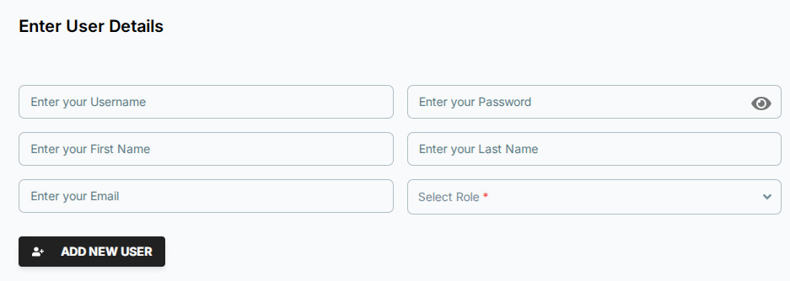

6.3 Projects
The Projects module under Admin Management allows authorized users to create, view, manage, and organize projects within the NPCYF platform. This section acts as the central workspace for defining projects and associating users and datasets with them.
Navigation Path:
Dashboard → Admin Management → Projects

6.3.1 Your Projects
The Your Projects section displays a list of all projects available to the user based on their role and access permissions.
Project List Table
Each project is displayed with the following details:
- Title – Name of the project.
- Description – Brief description of the project’s purpose.
- Date of Creation – The date when the project was created.
- Edit – Allows modification of project details.
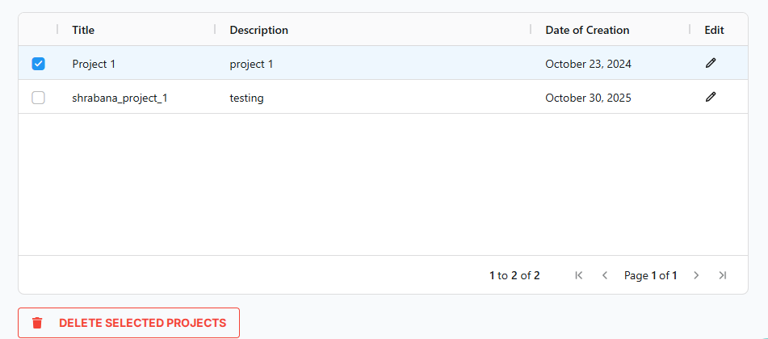
- Selection Checkbox – Used to select one or more projects for deletion.

Actions
- Edit Project
Click the edit (✏️) icon to update or to modify the project title or description.
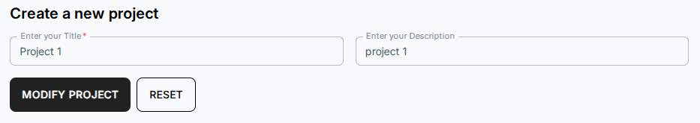
- Delete Selected Projects
Select one or more projects using the checkboxes and click DELETE SELECTED PROJECTS to remove them from the platform.

6.3.1.1 Create a New Project
The Create a New Project section allows users to add new projects to the platform.
Fields Description
- Title (Mandatory)
Enter a unique and meaningful name for the project.
- Description
Provide a brief description explaining the objective or scope of the project.
Actions
- Create Project
Click CREATE PROJECT to save and create the project. Once created, the project will appear in the Your Projects list.
- Reset
Click RESET to clear all entered fields.
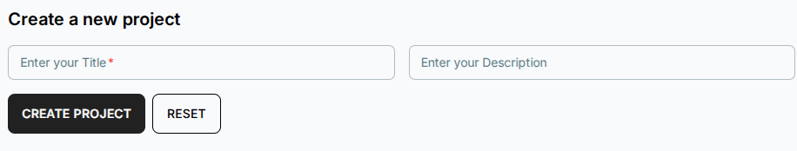

6.3.2 User – Project Association
The User – Project Association section is used to manage the assignment of users to specific projects within the NPCYF platform. This functionality ensures that users have access only to the projects relevant to their roles and responsibilities.
Purpose
This section enables administrators to associate or dissociate users with projects, thereby enforcing project-level access control and supporting secure collaboration.
Functionality
- Select Project (Mandatory)
Choose a project from the dropdown list. Once a project is selected, the system allows administrators to manage user associations for that specific project.
- Associate Users
Assign selected users to the chosen project, granting them access to work on that project based on their assigned roles.
- Dissociate Users
Remove users from a project when access is no longer required, ensuring controlled and up-to-date permissions.

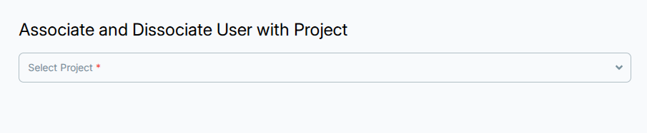

6.3.3 Dataset – Project Association
The Dataset – Project Association section allows administrators and authorized users to link or unlink datasets with specific projects. This ensures that each project has access only to the datasets relevant to its objectives, supporting secure and organized data usage.
Purpose
This section is designed to manage dataset accessibility at the project level, enabling controlled data sharing and maintaining data governance across the platform.
Functionality
- Select Project (Mandatory)
Choose a project from the dropdown list. Once selected, datasets can be associated or dissociated for that project.
- Associate Datasets
Link one or more datasets to the selected project, making them available for use within that project’s workflows and analyses.
- Dissociate Datasets
Remove datasets from a project when they are no longer required, ensuring only relevant data remains accessible.

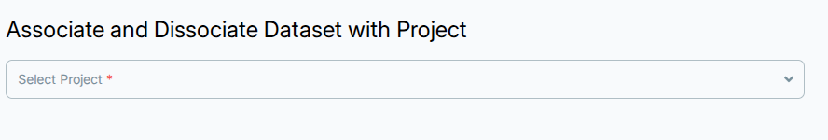

Purpose and Outcome
The Projects module ensures structured project management by:
- Organizing work into clearly defined projects.
- Controlling user and dataset access at the project level.
- Supporting collaboration, governance, and efficient workflow management across the platform.
This module forms the backbone of project-driven operations within the NPCYF platform.

6.4 Master Data Management
The Master Data Management module under Admin Management is used to define, maintain, and manage core reference data required across the NPCYF platform. This data acts as standardized inputs for multiple workflows, ensuring consistency, accuracy, and uniformity throughout the system.
Navigation Path:
Dashboard → Admin Management → Master Data Management
Overview
Master Data includes essential reference entities such as Season, Crop, State, and District, which are commonly used across ingestion, processing, analysis, and reporting modules. Administrators can add, update, delete, or bulk-upload these values from this section.
Components of the Screen
1. Type of Master Data (Dropdown)
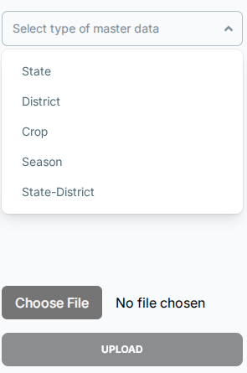
Use the Type of master data dropdown to select the category you want to manage. Available options include:
- Season
- Crop
- State
- District
The table on the right updates dynamically based on the selected master data type.

Master Data Types

6.4.1 Season
- Displays predefined agricultural seasons such as Kharif, Rabi, Summer, etc.
- Used across datasets and forecasting workflows.
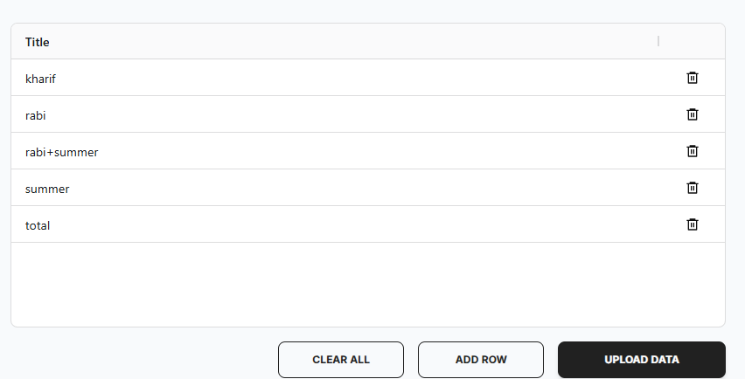
- Administrators can add new seasons or remove existing ones if required.

6.4.2 Crop
- Displays the list of supported crops (e.g., bajra, barley, cotton, cereals, etc.).
- These values are used during data ingestion and analysis.
- Administrators can add new crops or remove existing ones if required.

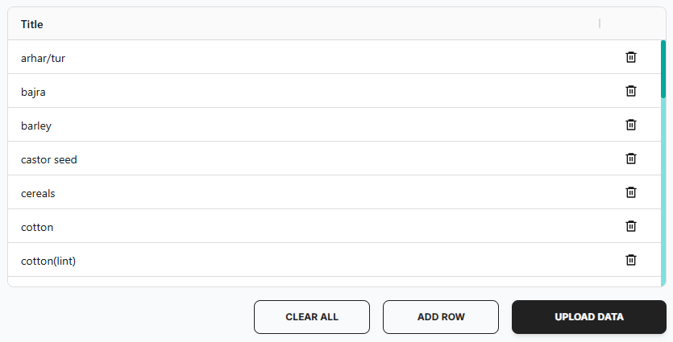
6.4.3 State
- Displays the list of Indian states and union territories.
- These values are used as geographical identifiers across the platform.
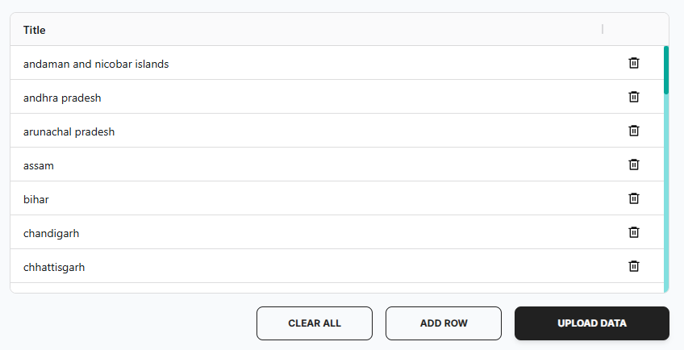
- Administrators can add new state or remove existing ones if required.

6.4.4 District
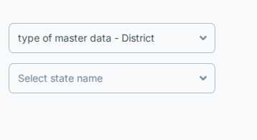
- Requires State selection before displaying district data.
- Once a state is selected, the corresponding districts can be viewed and managed.
- Ensures correct state–district hierarchy and prevents data inconsistency and duplication.
- Administrators can add new districts or remove existing ones if required.
Purpose and Benefits
- Ensures standardized reference data across all platform modules.
- Reduces data duplication and inconsistency.
- Enables controlled updates through authorized administrators.
- Supports scalability through bulk upload functionality.
- Maintains clean hierarchical relationships (e.g., State → District).

6.5 Copilot Configuration
The Copilot Config module under Admin Management is used to define, manage, and monitor AI Copilot configurations within the NPCYF platform. This module allows administrators to control how the Copilot behaves by configuring schemas, prompts, and activation status, ensuring consistent and governed AI-assisted interactions.
Navigation Path: Dashboard → Admin Management → Copilot Config

6.5.1 About the CoPilot
The NPCYF CoPilot is an AI-powered conversational assistant integrated into the platform to provide users with intelligent, context-aware support. It helps users interact with the system more efficiently by answering queries, providing guidance, and assisting with data-related tasks.
Key Features:
- Conversational Interface – Users can interact with the CoPilot through a natural language chat interface, making it easy to ask questions and receive instant responses.
- Context-Aware Responses – The CoPilot uses configured schemas and prompts to understand the data structure and provide relevant, accurate answers based on the platform's datasets and workflows.
- Customizable Behavior – Administrators can define how the CoPilot responds by creating and managing different configurations with specific prompts and schemas tailored to various use cases.
- Session Management – Users can refresh the session at any time to start a new conversation, ensuring clean and focused interactions.

User Interface:
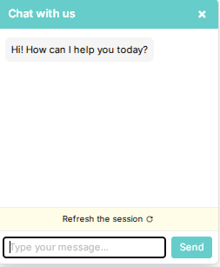
The CoPilot interface features:
- A chat window with a friendly greeting: "Hi! How can I help you today?"
- A message input field for users to type their queries
- A "Send" button to submit questions
- A "Refresh the session" option to restart the conversation
How It Works:
- Users access the CoPilot from within the platform
- They type questions or requests in natural language
- The CoPilot processes the query using the active configuration's schema and prompt
- It returns intelligent, contextual responses based on the platform's data and defined behavior
The CoPilot Configuration section allows administrators to create, modify, and manage these AI configurations to ensure the CoPilot delivers accurate and helpful assistance aligned with platform objectives and governance standards.

6.5.2 Definition
The Definition section is used to create and manage Copilot configurations.
Configuration List Table
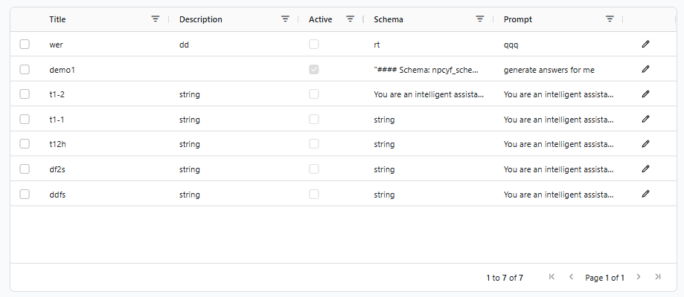
Displays existing Copilot configurations with the following columns
Title – Name of the Copilot configuration (e.g., "demo1", "t1-2", "wer")
- Description – Brief explanation of the configuration's purpose
- Active – Checkbox indicating whether the configuration is currently enabled (checked = active)
- Schema – Defines the data structure or context used by the Copilot (e.g., database schema, table structures)
- Prompt – Instruction that guides Copilot behavior (e.g., "generate answers for me", "You are an intelligent assistant...")
- Edit – Pencil icon (✏) allowing modification of an existing configuration
- Selection Checkbox – Located on the left of each row for selecting configurations for bulk operations
The table also includes:
- Pagination controls at the bottom ("1 to 7 of 7", "Page 1 of 1")
- Sorting capabilities on each column header
- Visual indication of active configurations with checked boxes in the Active column
This table helps administrators quickly review and manage available Copilot setups.
Create / Edit Copilot Configuration
Below the table, administrators can add or modify Copilot configurations using a form with the following fields :

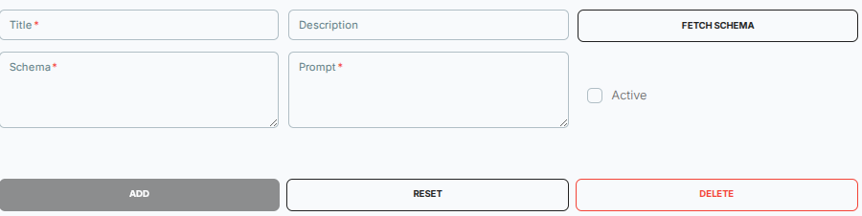
Form Fields:
- Title (Mandatory - indicated by red asterisk *)
  - Enter a unique and descriptive name for the Copilot configuration
  - Example: "demo1", "Data Collection Assistant"
- Description
  - Provide a short description explaining the purpose or use case of the configuration
  - Example: "Assists users with data collection queries"
- Schema (Mandatory - indicated by red asterisk *)
  - Define or review the schema that structures Copilot inputs and outputs
  - The schema field displays database schema information in a structured format
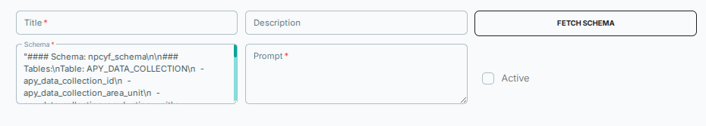

- This defines the database tables, columns, and relationships the Copilot can reference
- Prompt (Mandatory - indicated by red asterisk *)
  - Enter the instruction that determines how the Copilot should respond and behave
  - Example: "You are an intelligent assistant helping users with agricultural data queries. Use the provided schema to answer questions accurately."
Action Buttons:
- FETCH SCHEMA (top right button)
  - Click to automatically retrieve the relevant database schema
  - Populates the Schema field with current platform data structures
  - Ensures the Copilot has access to the latest schema information
- Active (checkbox on the right)
  - Enable this checkbox to make the configuration active
  - Only active configurations are used by the system
  - When checked, the configuration becomes available for use in the CoPilot interface
- ADD (gray button, bottom left)
  - Saves a new Copilot configuration
  - Adds the configuration to the table above
- RESET (white button, center)
  - Clears all entered fields in the form
  - Useful for starting fresh without saving
- DELETE (red button, bottom right)
  - Removes the selected configuration
  - Only available when editing an existing configuration
This configuration allows the Copilot to answer questions about agricultural production yield data by referencing the specified database schema.

6.5.3 Logs
The Logs section provides visibility into Copilot usage and activity.
- Helps administrators monitor execution, usage patterns, and potential issues
- Supports auditing, debugging, and performance tracking
- Enables review of user interactions and Copilot responses
Purpose and Benefits
- Ensures controlled and consistent AI behavior across the platform
- Enables structured prompt and schema management
- Allows easy activation or deactivation of Copilot features
- Supports transparency and governance through logs
- Provides flexibility to create multiple configurations for different use cases
- Ensures the Copilot has accurate, up-to-date schema information through the Fetch Schema feature

